

Capstone Project Report
Report 2 – Project Management Plan

– Ho Chi Minh, February 2025 –

Table of Contents
I. Record of Changes 3
II. Project Management Plan 4
1. Overview 4
1.1 Scope & Estimation 4
1.2 Project Objectives 5
1.3 Project Risks 5
2. Management Approach 6
2.1 Project Process 6
2.2 Quality Management 7
2.3 Training Plan 7
3. Project Deliverables 7
4. Responsibility Assignments 8
5. Project Communications 8
6. Configuration Management 9
6.1 Document Management 9
6.2 Source Code Management 9
6.3 Tools & Infrastructures 9

I. Record of Changes
Date | A*  M, D | In charge | Change Description
10/02/2025 | A | Nam | Add Configuration Management
10/02/2025 | A | Nam | Add Project Communications
10/02/2025 | A | An | Add Responsibility Assignments
30/04/2025 | A | Luân | Add from final report
*A - Added M - Modified D - Deleted

II. Project Management Plan

1. Overview

1.1 Scope & Estimation
# | WBS Item | Complexity | Est. Effort  (man-days)
1 | Initiating
1.1 | Collect requirement | Medium | 14
2 | Planning
2.1 | Create plan document | Complex | 10
3 | Executing
3.1 | Analysis
3.1.1 | Analysis requirement | Complex | 12
3.2 | Design and prototyping
3.2.1 | Design customer web/mobile application | Complex | 20
3.2.2 | Design customer web/mobile application | Complex | 20
3.2.3 | Design platform’s staff web application | Complex | 15
3.3 | Implementation
3.3.1 | Implement base feature
3.3.1.1 | Login and logout | Simple | 2
3.3.1.2 | Update profile | Simple | 2
3.3.1.3 | Register | Simple | 2
3.3.1.4 | Change and reset password | Simple | 2
3.3.2 | Implement woodworker feature
3.3.2.1 | Manage service | Medium | 4
3.3.2.2 | Manage product | Medium | 2
3.3.2.3 | Manage design idea | Complex | 8
3.3.2.4 | Manage post | Medium | 2
3.3.2.5 | Manage service order | Complex | 20
3.3.2.6 | Manage guarantee order | Complex | 20
3.3.2.7 | Manage wallet | Medium | 10
3.3.2.8 | Manage customer complaint | Medium | 5
3.3.2.9 | Manage review | Medium | 2
3.3.3 | Implement customer feature
3.3.3.1 | Search, filter, view list/detail woodworker | Medium | 3
3.3.3.2 | Search, filter, view list/detail product | Medium | 3
3.3.3.3 | Search, filter, view list/detail design idea | Medium | 3
3.3.3.4 | Book and manage customization service | Complex | 15
3.3.3.5 | Book and manage personalization service | Complex | 15
3.3.3.6 | Review and rating order | Medium | 2
3.3.3.7 | Manage wallet | Medium | 10
3.3.3.8 | Manage complaint | Medium | 10
3.3.4 | Implement moderator feature
3.3.4.1 | Manage woodworker performance | Medium | 6
3.3.4.2 | Send performance email | Medium | 3
3.3.5 | Implement staff feature
3.3.5.1 | Manage customer’s review | Medium | 3
3.3.5.2 | Mange woodworker’s response | Medium | 3
3.3.5.3 | Manage complaint | Complex | 10
3.3.6 | Implement admin feature
3.3.6.1 | Manage woodworker registration | Medium | 10
3.3.6.2 | Manage configuration | Medium | 10
3.4 | Testing
3.4.1 | Unit testing | Complex | 12
3.4.2 | Integration test | Complex | 12
3.4.3 | System test | Complex | 12
4 | Monitoring and controlling
4.1 | Control the process | Complex | 12
4.2 | Track performance and quality | Complex | 12
5 | Closing
5.1 | Report | Simple | 20
Total Estimated Effort (man-days) |  |  | 358

1.2 Project Objectives
# | Testing Stage | No. of Defects | % of Defect | Notes
1 | Reviewing | 20 | 27,6%
2 | System Test | 40 | 72,4%
3 | User Acceptance Test | X | X
Total |  | 60 | 100%

1.3 Project Risks
# | Risk Description | Impact | Possibility | Response Plans
1 | Technology risk: cannot find the suitable solution for technique problems, the software cannot fulfil the expectation. | High | Medium | Do more research on official  resources, discuss with  mentor.
2 | Requirement changes: requirements unexpected  Changes. | Critical | Medium | Chose another way of solution  to respond to those changes.

2. Management Approach

2.1 Project Process
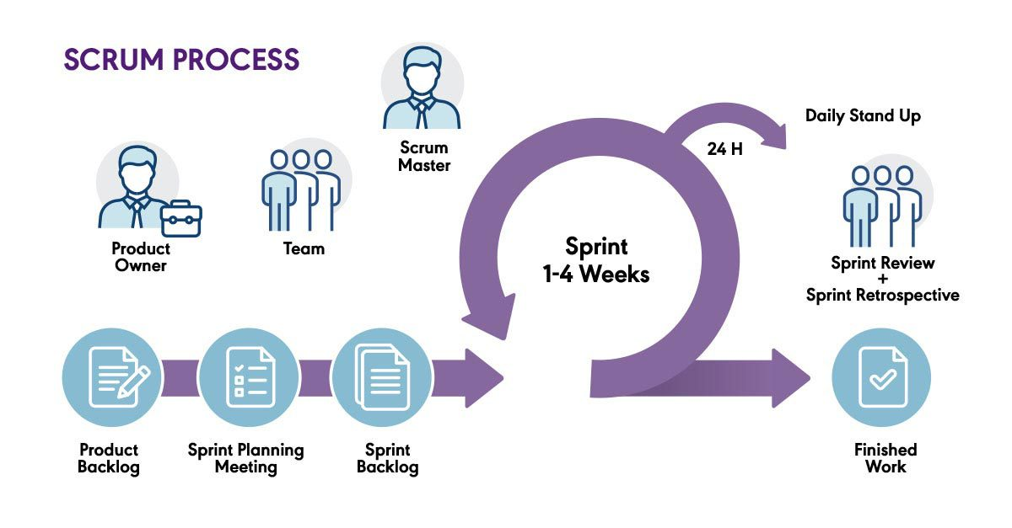References: What is Scrum? | The Agile Journey: A Scrum overview
Our project, adopted the Scrum model, an Agile framework for software development, for the following reasons:
- We worked with a small team of 4 members, making it unnecessary to follow every stage of a traditional methodology like Waterfall. Instead, Scrum allowed us to iterate quickly and focus on delivering value continuously.
- By organizing work into short sprints, we were able to easily analyze the next priorities and refactor whenever necessary, ensuring flexibility throughout the development cycle.
- The limited time frame of each sprint created a healthy pressure, motivating the team to complete tasks efficiently and maintain momentum across the project.
Product backlog
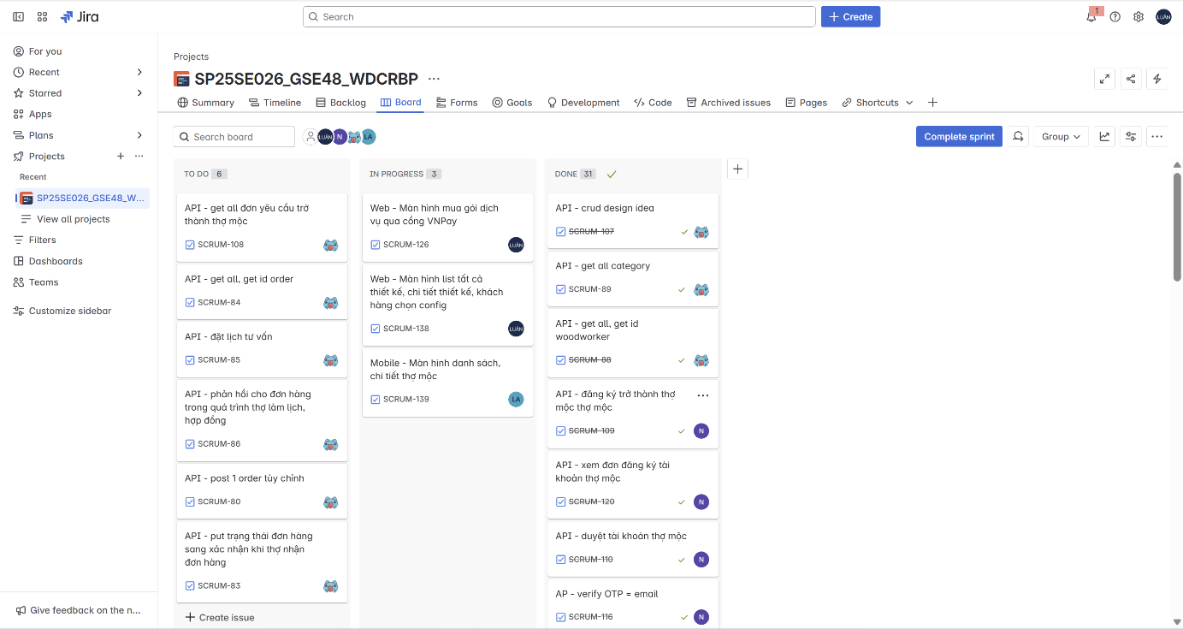

2.2 Quality Management
To maintain code and project quality:
- Conduct regular code reviews.
- Enforce consistent coding standards.
- Feedback loop: Demos and user feedback sessions every sprint.

2.3 Training Plan
Training Area | Participants | When, Duration | Waiver Criteria
Git & GitHub Workflow | All Members | Week 1 only | Mandatory
Jira + Agile Practice | All Members | Week 1 only | Mandatory
ReactJS Essentials | Võ Trọng Luân | Week 1 – Week 2 | Mandatory
React Native Basics | Võ Trọng Luân  Lê Nguyên An  Nguyễn Đặng Phương | Week 1 – Week 2 | Mandatory
Spring Boot Core | Trần Việt Phúc  Nguyễn Đặng Phương Nam | Week 1 – Week 2 | Mandatory

3. Project Deliverables
# | Deliverable | Due Date | Notes
1 | User Requirements Document (URD) | 22/02/2025 | Defines user needs and expectations.
2 | Software Requirements Specification (SRS) | 22/02/2025 | Outlines detailed functional and non-functional requirements.
3 | System Architecture Design | 22/02/2025 | Includes high-level system design, database schema, and component interactions.
4 | Web Application | 05/04/2025 | A web-based platform for guests, customers, woodworkers, and administrators with full functionality for booking services, reviews, account management, etc.
5 | Mobile Application | 05/04/2025 | A user-friendly mobile app optimized for seamless user experience with features like the web application.
6 | Backend System (RESTful API) | 05/04/2025 | Backend system ensuring authentication, service management, chat support, cost calculations, and payment integration.
7 | Database System | 22/02/2025 | Data management system using MySQL/SQL Server with key tables such as Users, Bookings, Services, Payments, Reviews, etc.
8 | Deployment & Hosting Deliverables | 05/04/2025 | Includes source code, server configuration, and deployment documentation on Railway.
9 | Final Report & Presentation | 28/04/2025 | A final report summarizing the development process, achieved results, challenges faced, along with a presentation and product demo video

4. Responsibility Assignments
D~Do; R~Review; S~Support; I~Informed; <blank>- Omitted

Responsibility | luanvtse171436 | phuctvse171429 | anlnse171475 | namndpse171442
Project Planning & Tracking | D | D | D | D
Prepare Project Introduction Document | D | D | D | D
Prepare SRS Document (Overview Part) | D | D | D | D
Prepare SRS Document (User Requirements) | D | D | D | D
Develop System Architecture | D | D | D | D
Implement Backend Components | R | D | R | D
Implement Frontend Components | D | R | R | R
Implement App Components | S | R | D | S

5. Project Communications
Communication Item | Who/ Target | Purpose | When, Frequency | Type, Tool, Method(s)
Texting | Supervisor +  Team  member | • Confirm Meeting time  • Report Working progress  • Internal conversations | Usually | Zalo
Meeting offline | Supervisor +  Team  member | • Progress report  • Report and handle problem  • Review task | Weekly
Tracking  progress | Team  member | • Check personal tasks  • Tracking progress of project on Jira | Daily | Jira

6. Configuration Management

6.1 Document Management
- Use OneDrive to save document and for real-time editing on Microsoft Word.
- Use Google Drive to save meeting report, meeting record, diagram, image, design, document to each category folder

6.2 Source Code Management
- GitHub server to store source code.
- Follow the rule of team when using Git:
  - Commit and note the changes details often.
  - Review carefully before push into develop branch.
  - Fetch, review and resolve conflicts when merging usually

6.3 Tools & Infrastructures
Category | Tools / Infrastructure
Technology | React (Web), React Native (Mobile), Spring Boot (Back-end)
Database | MySQL
IDEs/Editors | Visual Studio Code, IntelliJ
Diagramming | Visual Paradigm, DrawIO, Mermaid Chart
Documentation | Ms Office, Google Docs/Sheets/Slides
Version Control | GitHub (Source Codes), Google Drive (Documents)
Deployment server | Railway, Vercel
Project management | Jira (Schedule), GitHub (Tasks, Defects)

